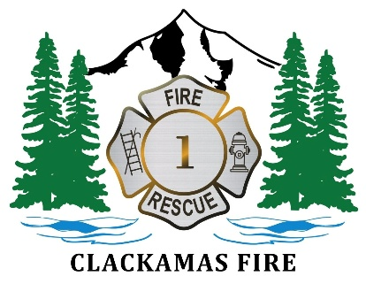
Clackamas Fire District is accepting applications for the volunteer position of Civil Service Chief Examiner. This appointed position carries no salary or benefits and serves a four-year term that will expire on October 13, 2030.
Applications must be submitted no later than Sunday, September 6, 2026. The Civil Service Commission will review applications, interview qualified candidates, and make an appointment at its meeting on October 14, 2026, or upon receipt of an application.
Mail applications to:
Clackamas Fire District
Attn: Nannette Howland
11300 SE Fuller Road
Milwaukie, OR 97222

Or

Email to:
nannette.howland@clackamasfire.com

Civil Service Chief Examiner Application
Name ______________________________________
Address _____________________________________
_____________________________________
Telephone # _____________________________________
E-mail _____________________________________

Please provide a written explanation of your interest in the position of Civil Service Commissioner.

